**6-Port Industrial PoE+ Gigabit Managed Ethernet Switch, w/ 4*10/100/1000Tx (30W/Port), 1*10/100/1000Tx Fast Ethernet, and 1*100/1000 SFP Slot, 48~55VDC**

**Features**

► Supports 4*10/100/1000Tx IEEE 802.3at/af Compliant with 30W/Port, + 1*10/100/1000Tx, and 1*100/1000 SFP Slot

► Network Redundancy Support: RSTP/MSTP, and TG.8032 ERPS (Recovery Time <50ms)

► Configuration: Web Console, Telnet, CLI Command

► Supports IGMP v1/v2, up to 256 Groups

► Supports QoS (IEEE802.1p) and CoS/ToS

► Supports IEEE802.1Q VLAN, SNMP v1/v2c

► System Warning Setting for Automatic Warning through

Email

► Redundant Power Input Design: 48~55VDC

► Housing: Metal IP 30 Rated; DIN-Rail and Wall Mount

Support

**►** Operating Temperature - STD: -10~70C & EOT: -40~75C

► 5-Year Warranty

**LMP-0601G-SFP Series**

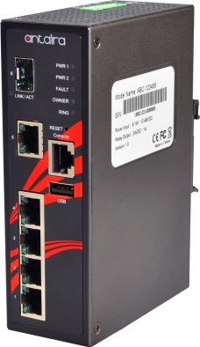



**INTRODUCTION**

**Antaira’s LMP-0601G-SFP series** is a 6-port industrial PoE+ gigabit managed Ethernet switch that is embedded with 4*10/100/1000Tx Ethernet ports that support IEEE802.3at/af for a maximum of 30 watts per port, 1*10/100/1000Tx Fast Ethernet port, and 1*100/1000 dual rate SFP slot for fiber connection.

LMP-0601G-SFP series is a fully manageable industrial Ethernet switch pre-loaded with standard Layer 2 network management software, and supports a user friendly web console interface for easy configuration. This product series is IP30 rated, DIN-rail mountable, and has two wide operating temperature models for either a standard temperature range ( STD: -10°C to 70°C) or an extended temperature range (EOT: -40°C to 75°C). It also provides high EFT and ESD protection for any industrial networking application within factory automation, ITS, power/utility, water wastewater, and any other outdoor or harsh environment.

automation, ITS, power/utility, water wastewater treatment plants, any outdoor or harsh environment.





**DIMENSIONS**

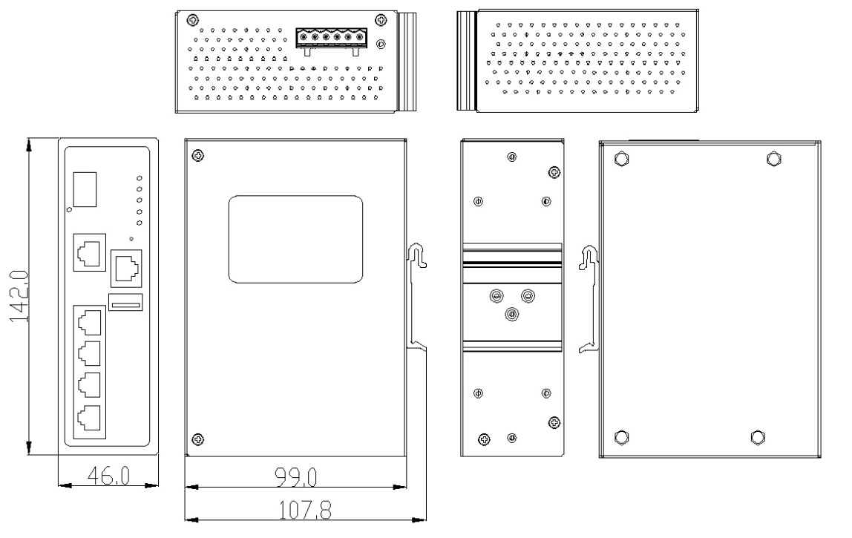



**SPECIFICATIONS**

|  |  |  |  |
| --- | --- | --- | --- |
| **Technology** | |  | |
| **Stanars** | | IEEE 802.3 10Tx Ethernet  IEEE 802.3u 100Tx Fast Ethernet  IEEE 802.3ab 1000BaseT  IEEE 802.3z 1000Base-X  IEEE 802.3x Flow Control for Full Duplex  IEEE 802.3at/af PoE (Power-over-Ethernet)  IEEE 802.1 STP (Spanning Tree Protocol)  IEEE 802.1w RSTP (Rapi Spanning Tree Protocol)  IEEE 802.1s MSTP (Multiple Spanning Tree Protocol)  ITU-TG.8032 / Y.1344 ERPS (Ethernet Ring Protection Switch)  IEEE 802.1q Virtual LANs (VLAN)  IEEE 802.1x Network Authentication  IEEE 802.1a Stacke VLAN, Q-in-Q  IEEE 802.1p QoS/CoS Protocol for Traffic Prioritization | |
| **Switch Properties** | | |  |
| **Protocol** | CSMA/CD,IGMPv1/v2,SNMPv1/v2,TFTP,SNTP,SMTP,RARP, Syslog | | |
| **Configuration** | Web Console, Telnet, CLI | | |
| **Transfer Rate** | 14,880pps for 10Base-T Ethernet port  148,8800pps for 100Base-T Fast Ethernet port  1,488,000pps for Gigabit Ethernet Port | | |
| **Packet Buffer** | 1 Mbits | | |
| **MAC Table** | 8K | | |
| **Jumbo Frame** | 9.6K | | |
| **Flow Control** | IEEE 802.3x for full uplex moe, back pressure for half uplex moe | | |
| **VLAN Group** | 0 ~ 4094 | | |
| **IGMP Group** | Up to 256 Groups | | |
| **Port Interface** | | |  |
| **Ethernet RJ45 Port** | 5*10/100/1000BaseTx (30W/Port for Port 1~4 only), auto negotiation spee, Full/Half uplex moe, an auto MDI/MDI-X connection | | |
| **Fiber Port** | 1* 100/1000 SFP Slot | | |
| **Wavelength** | Refer to SFP Moules | | |
| **PoE Port Pin Assignment** | V+, V+, V-, V-, for pin 1, 2, 3, 6 (Enspan, MDIAlternative A) | | |
| **Serial Console** | 1*RS232 in RJ45 connector with console cable, 115.2Kbps, 8,N,1 | | |
| **Configuration Backup** | 1*USB 2.0 | | |

|  |  |  |
| --- | --- | --- |
| **Protection** | |  |
| **Overloa Current** | Present | |
| **Power Reverse Polarity** | Present | |
| **CPU Watchog** | Present | |
| **Network Cable** | 10Base-T: 2-pair UTP/STP Cat. 3, 4, 5 cable; 100Base-TX: 2-pair UTP/STP Cat. 5 cable. EIA/TIA-568 100-ohm (100m)  1000BaseTX: UTP/STP Cat.5/5E cable; EIA/TIA-568 100-ohm (100m) | |
| **Mechanical Characteristics** | |  |
| **LED Inicator** | Per Unit: Power 1 & 2 (Green), Fault (Re) | |
| **Housing** | Metal IP30 rate | |
| **Dimension** | 46 x 142 x 99 mm | |
| **Weight** | Unit: 1.5 lbs.; Shipping: 2.3 lbs. | |
| **Mounting** | DIN-Rail; Wall-mount (optional) | |
| **Power Requirement** | | |
| **Input Voltage** | 48~55VDC Reunant Input | |
| **Power Connection** | 1 removable 6-contact terminal block | |
| **PoE Power Output** | 25W @ 48VDC (per PoE port);  30W @ 51~55VDC (per PoE port) | |
| **Power Consumption** | 10 Watts (no PD inclue);  130 Watts (Fully loae) | |
| **Environmental Limits** | | |
| **Operating Temperature** | STD: -10° to 70° C  EOT: -40° to 75° C | |
| **Storage Temperature** | -40°C ~ 85°C | |
| **Ambient Relative Humiity** | 5 to 95%, (non-conensing) | |
| **Regulatory Approvals** | | |
| **EMI** | FCC Class A | |
| **EMS** | EN61000-4-2,3,4,5,6,8,  EN61000-6-2,4 | |
| **Free Fall** | IEC60068-2-32 | |
| **Shock** | IEC60068-2-27 | |
| **Vibration** | IEC60068-2-6 | |
| **Green** | RoHS Compliant | |
| **Certifications** | FCC, CE, UL508 | |
| **Warranty** | 5 Years | |

|  |  |  |
| --- | --- | --- |
| **LMP-0601G-SFP** | 6-Port Inustrial PoE+ Gigabit Manage Ethernet Switch with 4*10/100/1000Tx (30W/Port), 1*10/100/1000Tx, an 1* 100/1000 SFP Slot | |
| **LMP-0601G-SFP-T** | 6-Port Inustrial PoE+ Gigabit Manage Ethernet Switch with 4*10/100/1000Tx (30W/Port), 1*10/100/1000Tx, an 1* 100/1000 SFP Slot; EOT -40° to 75° C | |
| **Optional Accessories** | |  |
| **MDR-60-48** | 60W Inustrial Din Rail Power Supply, 48VDC | |
| **DR-75-48** | 75W Inustrial Din Rail Power Supply, 48VDC | |
| **DR-120-48** | 120W Inustrial Din Rail Power Supply, 48VDC | |
| **MDR-240-48** | 240W Inustrial Din Rail Power Supply, 48VDC | |



**ORDERING INFO**